Welcome to Senoia Raceway. We want to thank you in advance for being a part of our program. Please complete the information below as thoroughly as possible. This information is for our accounting records and will be used to promote you at our events.

Driver _____________________________________ Class __________________________ Car# _____________
Years Racing/Classes and Tracks (Highlights): ______________________________________________________ ___________________________________________________________________________________________
___________________________________________________________________________________________
Address_______________________________________________________________________
City _______________________________________ ST _________ Zip_________ DOB:_______________________ Day Time Phone (__________)_____________________________________ Evening Phone (__________)______________________________________ S/S#_______________/_____________/_____________ OR Fed ID_______________________________________ E-Mail ________________________________________________________________________ Owner __________________________________________ Address ___________________________________________________________________ City _________________________________ ST ___________ Zip_______ Day Time Phone (__________)_____________________________________ Evening Phone (__________)_____________________________________
E-Mail_________________________________________________________________________ Make of Car ______________________________________________ Year_______________ Model _________________________________________

Sponsor Info:
Sponsor________________________________________________________________________________

Sponsor________________________________________________________________________________

Sponsor________________________________________________________________________________

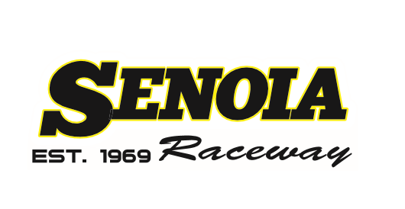

ENTRY AND ADVERTISING RELEASE: In consideration of the awards of this event and the sanctioning of the event by Senoia Raceway the car owner and driver individually and jointly agree that Senoia Raceway, LLC and its successors (and/or assigns) may use their name(s) and picture(s) of their person and car described herein, or any of them, in any way, medium or material for promoting, advertising, recording or reporting this event before, during and after such event, and do hereby relinquish all rights hereto for these purposes. Driver and car owner understand this entry form covers all events in connection with Senoia Raceway, LLC and that they understand and will abide by all rules, regulations and decisions as well as all stipulations in the entry blank Senoia Raceway 2021 rules will apply. Call the track at 770-599-6161 for rules or further information.
GOOD FAITH TO PUBLIC PLEDGE – In signing this entry blank, both driver(s) and car owner(s) recognize their obligation to the public and race promoter posting the prize money and conducting this event. Therefore, we agree to compete in the event if humanly possible unless this event is postponed, cancelled or if the car fails to qualify for the starting field.
Submitted for approval by: Signature: ___________________________
Date ___________/___________/___________
ANYONE UNDER 18 YEARS OF AGE MUST HAVE A PARENT OR LEGAL GUARDIAN SIGN A MINOR RELEASE FORM TO ENTER PIT. A DRIVER UNDER 18 YEARS OF AGE MUST HAVE BOTH PARENT’S OR LEGAL GUARDIAN’S ON MINOR RELEASE FORM NO EXCEPTIONS.

